Overview GET http://localhost:8989/a, • No environment v
http://localhost:8989/api/pr0ducts/1 Save v Share New Chat
Connect a folder to Postman and start working GET http://localhost:8989/api/pr0ducts/1 Send Start using Agent Model
directly with your files. Sync whenever you're Your plan includes 50 Al credits ready. Learn more 7 Docs Params Authorization Headers 8 Body • Scripts Settings Cook ies per month to use Agent Mode.
Open folder JSON Beautify
1
- " name " • " Laptop" ,
- "description" : "HP Victus" , 4 "price" :
5 "quantity" • 19
6
Body Cookies Headers 5 Test Results 200 OK 5 ms 241 B
{ } JSON v Preview g Visualize v (9
1
- " name " • " Laptop" , Fix update request essentials
- "description" : "HP Victus" ,
- "price" : Add negative-case assertions 5 "quantity" :
Create a parameterized update flow
6 "id" : 1
7
Describe what you need. Press @ for context, / for Skills.
Auto v
V Local View Terminal Console + The coast is clear! Globals Vault TOO'S
Overview DEL http:mocalhost:8989/a1 • No environment v
http://localhost:8989/api/pr0ducts/1 Save v Share New Chat
Work with local files
Connect a folder to Postman and start working DELETE http://localhost:8989/api/pr0ducts/1 Send Start using Agent Mode!
directly with your files. Sync whenever you're Your plan includes 50 Al credits ready. Learn more 7 Docs Params Authorization Headers 8 Body • Scripts Settings Cookies per month to use Agent Mode.
Open folder JSON Beautify
1
- " name " • " Laptop" ,
- "description" : "HP Victus" , 4 "price" :
5 "quantity" : 19
6
Body Cookies Headers 3 Test Results 204 NO Content 300 ms 102 B
Raw v Preview g Visualize v Q (9
1
Add negative assertions for delete
Reuse the delete test via script
Parameterize body for bulk creates
Describe what you need. Press @ for context, / for Skills.
@ Auto v
V Local V^{i}ew Terminal Console + The coast is clear! Vau't TOO'S ril

Connect a folder to Postman and start working directly with your files. Sync whenever you're ready. Learn more 7
Open folder
V Local View Terminal Console
Overview GET http://localhost:8989/a, NO v
http://localhost:8989/api/products Save v Share
GET http://localhost:8989/api/products Send
Docs Params Authorization Headers 8 BOdY Scripts Settings Cookies
JSON Beautify
1
2 " name " • " Laptop" , 3 "description" : "HP Victus" , 4 "price" :
5 "quantity" : 19
6
Body Cookies Headers 5 Test Results 200 OK • 7 ms 232 B
{ } JSON v Preview g Visualize v (9
1
2
3 " name " • " Laptop" , 4 "description" : "Victus" , 5 "price" :
- "quantity" :
- 2
- 9
+ The coast is clear!
New Chat
Start using Agent Mode!
Your plan includes 50 Al credits per month to use Agent Mode.
Add negative assertions for delete
Reuse the delete test via script
Parameterize body for bulk creates
Describe what you need. Press @ for context, / for Skills.
@ Auto v
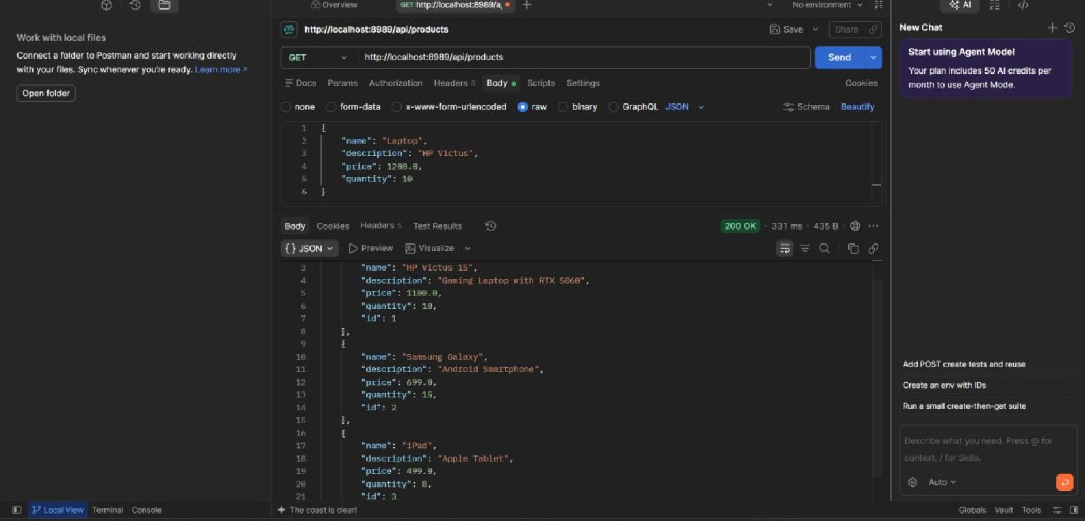
Globals Vault TOO'S

